Module 7: MariaDB Assignment
Problem Statement:
You work for XYZ Corporation. Their application requires a SQL service that can store data which can be retrieved if required. Implement a suitable RDS engine for the same.
While migrating, you are asked to perform the following tasks:
1. Create a MariaDB Engine based RDS Database.
2. Connect to the DB using the following ways:
a. SQL Client for Windows
b. Linux based EC2 Instance
Choosing the MariaDB engine:
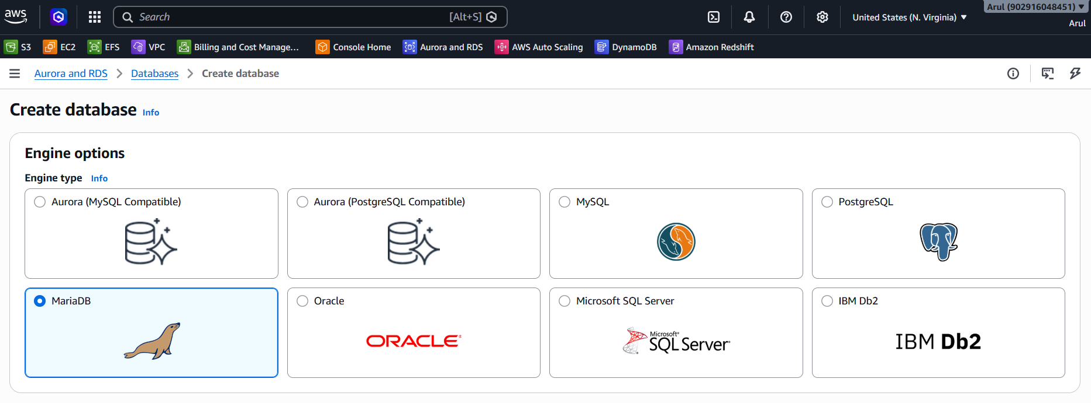
Configuration method & environment:
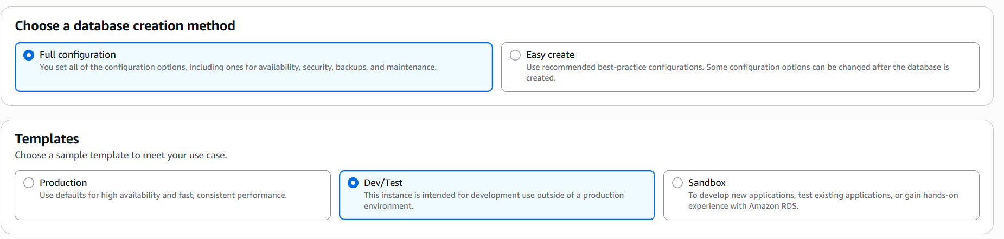
Selecting the DB engine version:
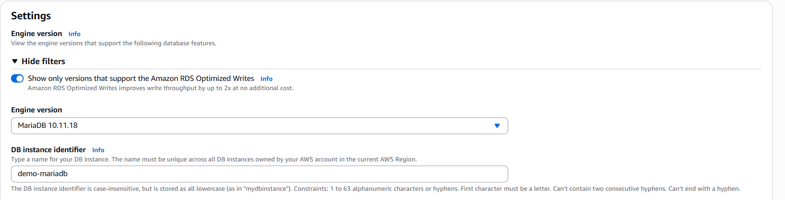
Choosing the credentials: admin and password
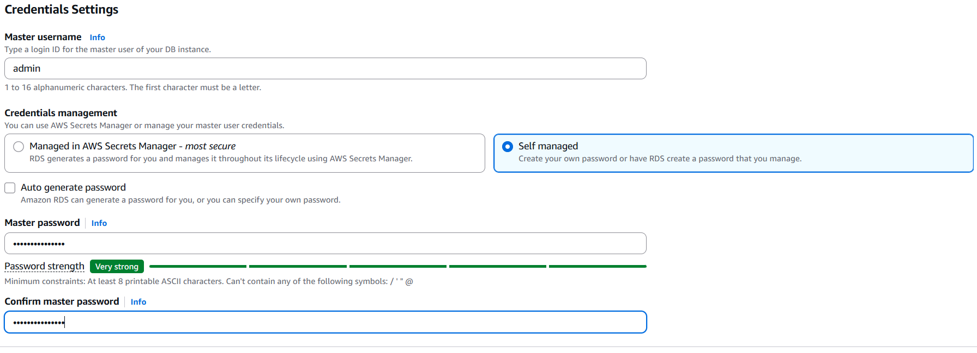
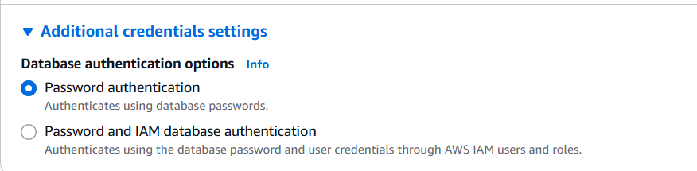
Choosing the DB instance type:
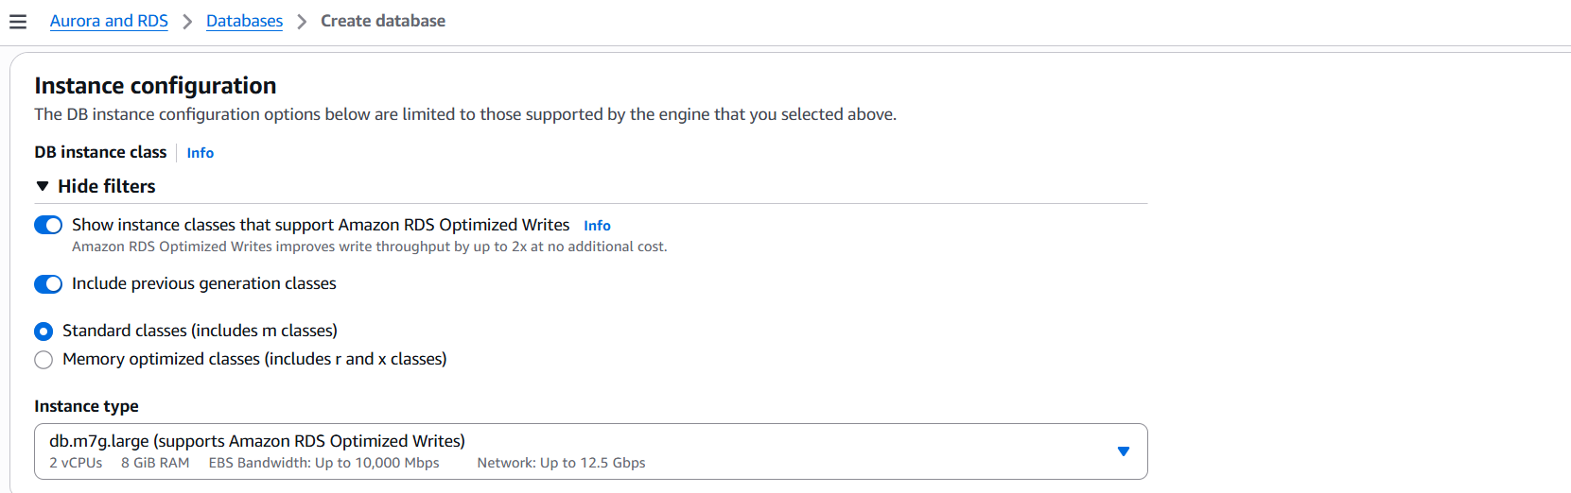
Storage Specifications & availability:
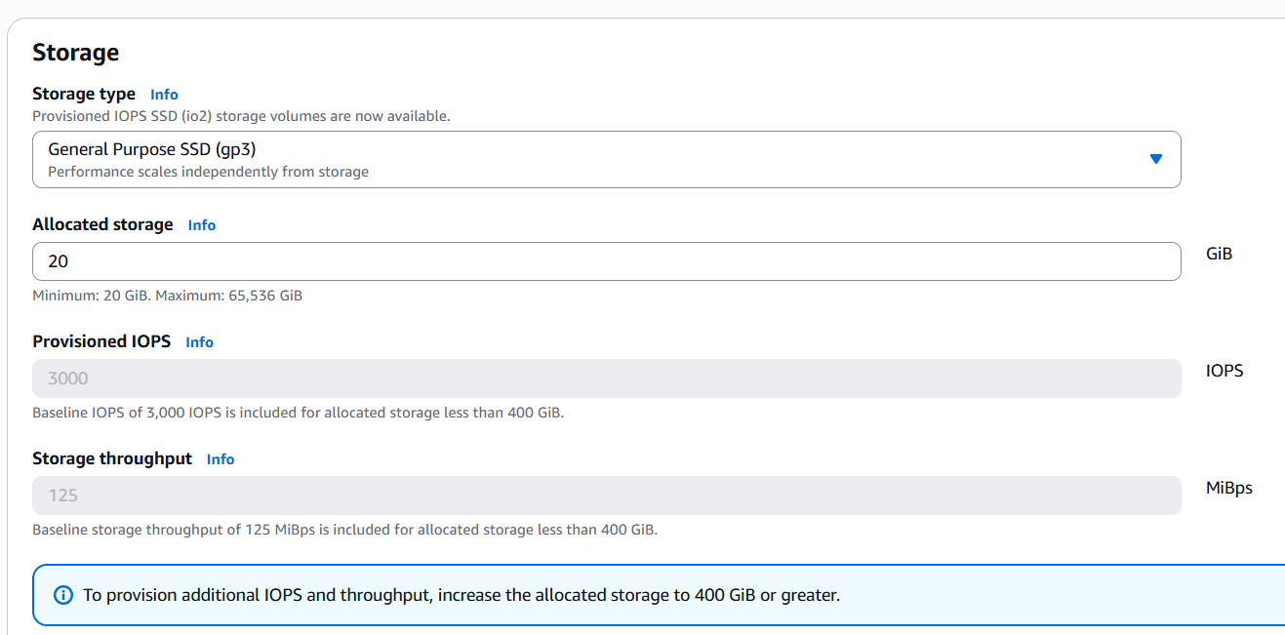
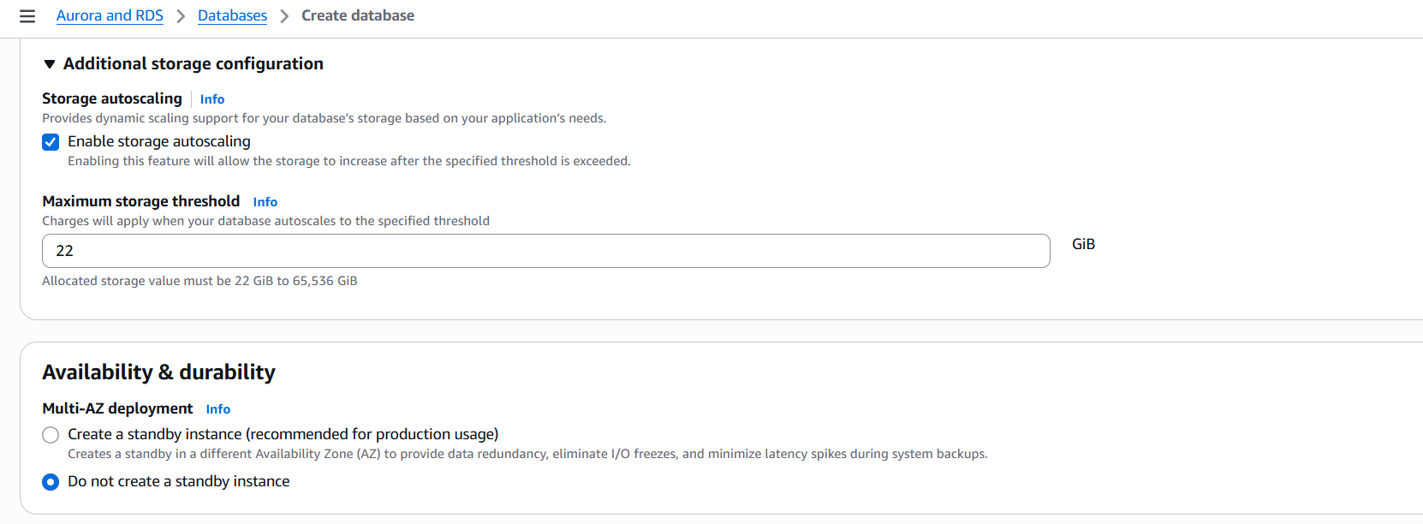
Connectivevity parameters:
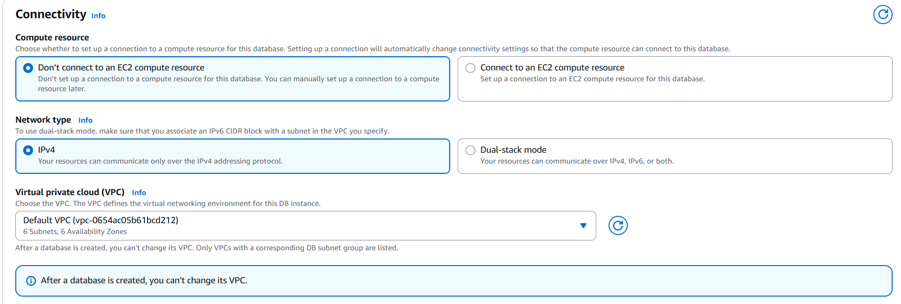

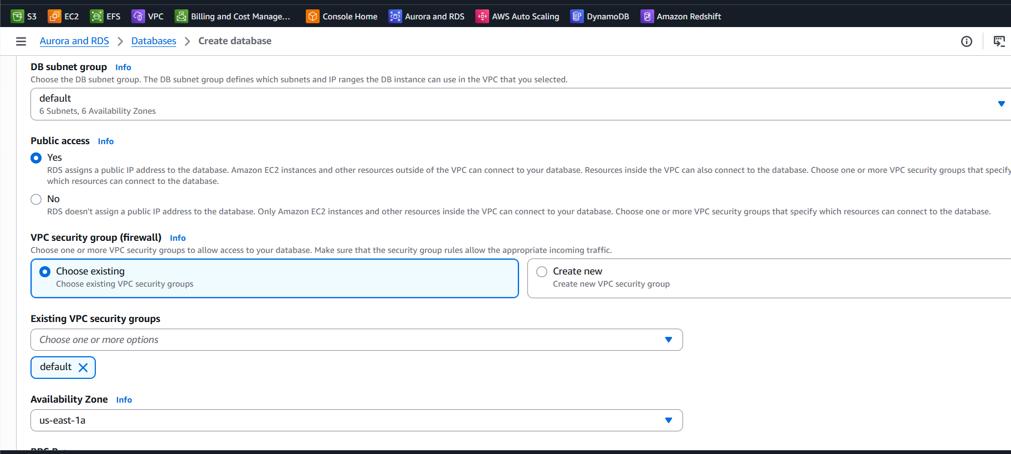
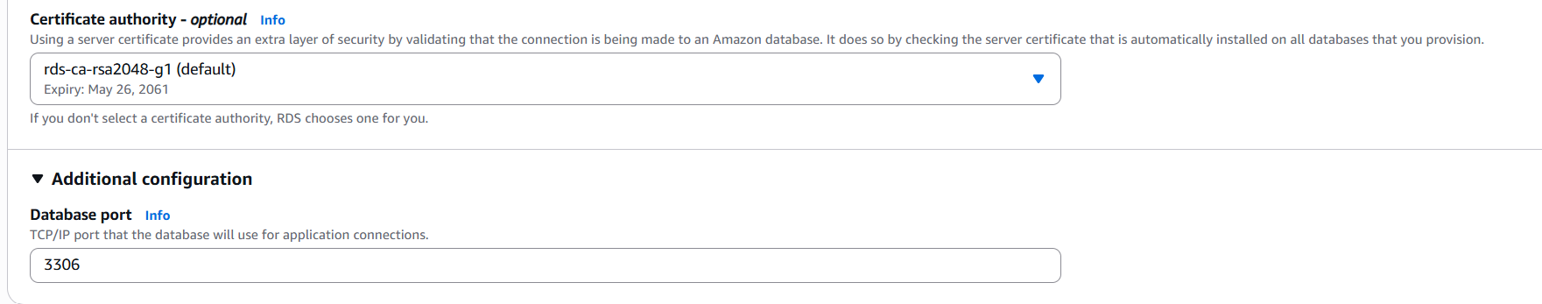
Additional Configurations:
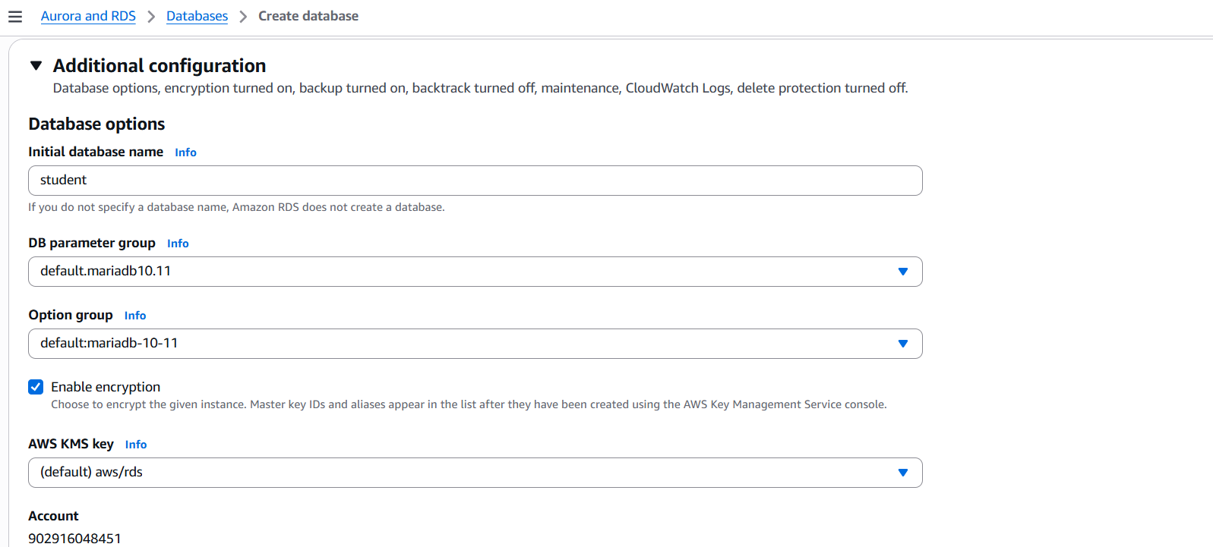
Database created: demo-mariadb
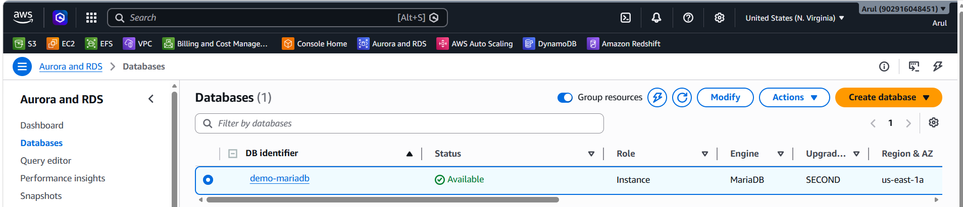
DB URL: demo-mariadb.csn4sywki1mn.us-east-1.rds.amazonaws.com
Connecting the DB with DBeaver on windows client:
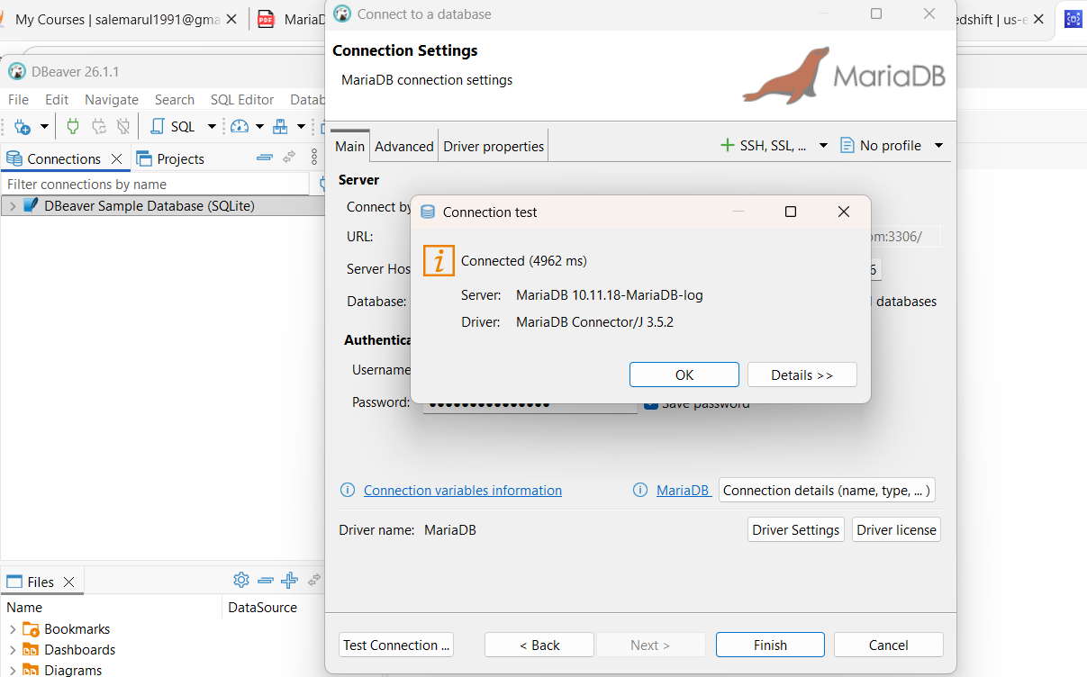
Creating the DB, table and inserting the data in the query prompt:
CREATE DATABASE school;
USE school;
CREATE TABLE students (
id INT PRIMARY KEY,
name VARCHAR(50),
department VARCHAR(50)
);
INSERT INTO students VALUES
(1,'Arul','IT'),
(2,'John','Finance'),
(3,'Mary','HR');
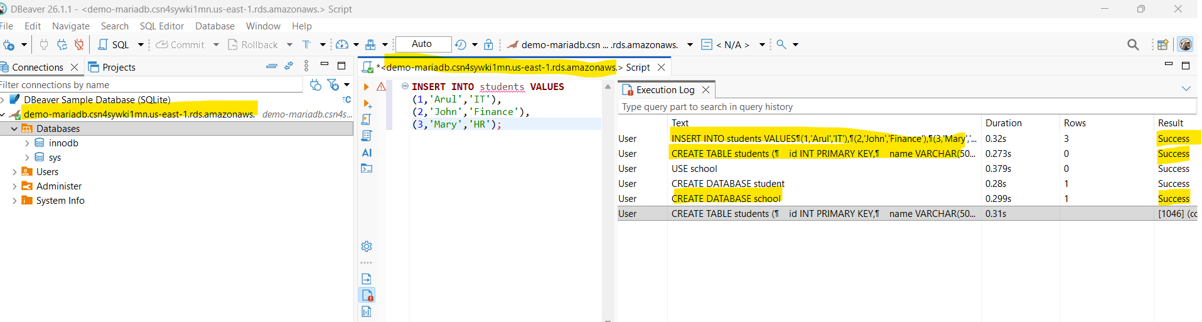
Retrieving the data from the client:
SELECT * FROM students;
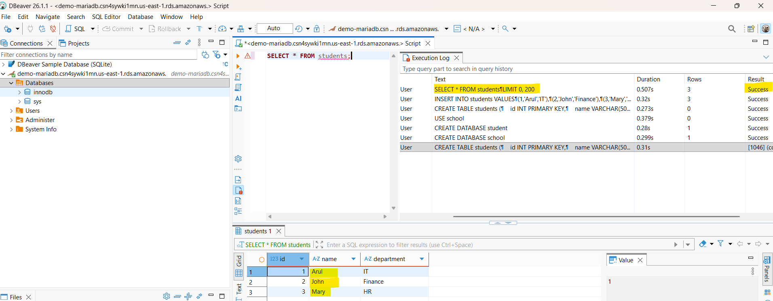
Connecting the DB with EC2 Linux Machine:
Choosing the Instance name & AMI:
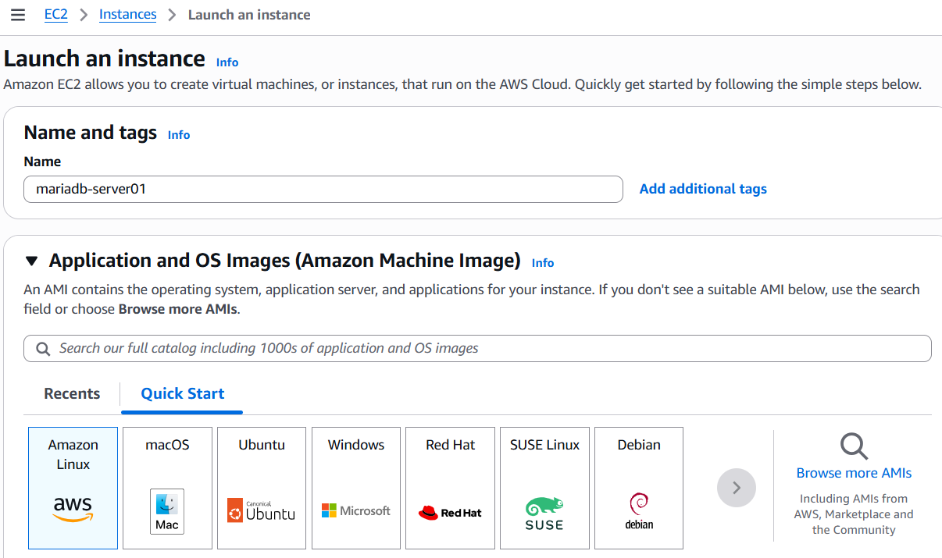
Select the Instance type:
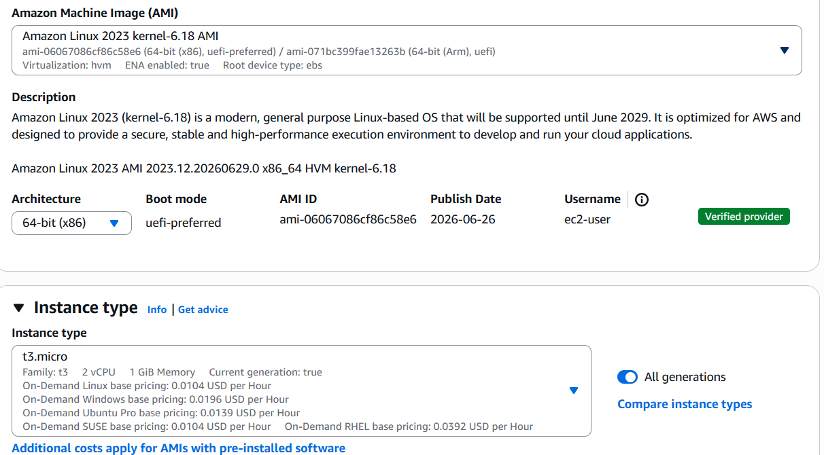

Selecting the same VPC where DB available:
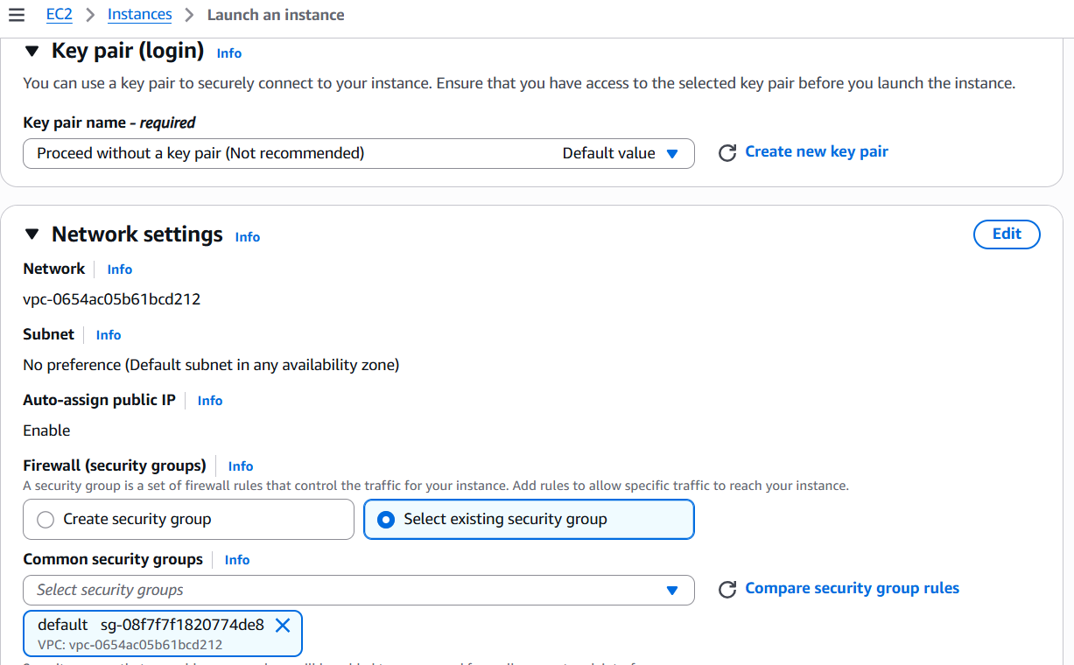
Storage Configurations:
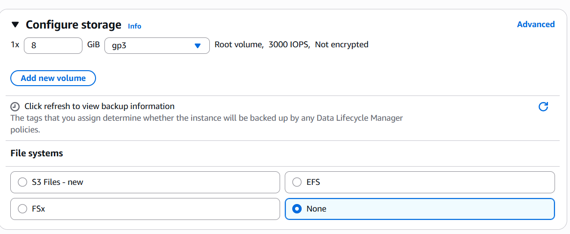
EC2 instance created: mariadb-server01
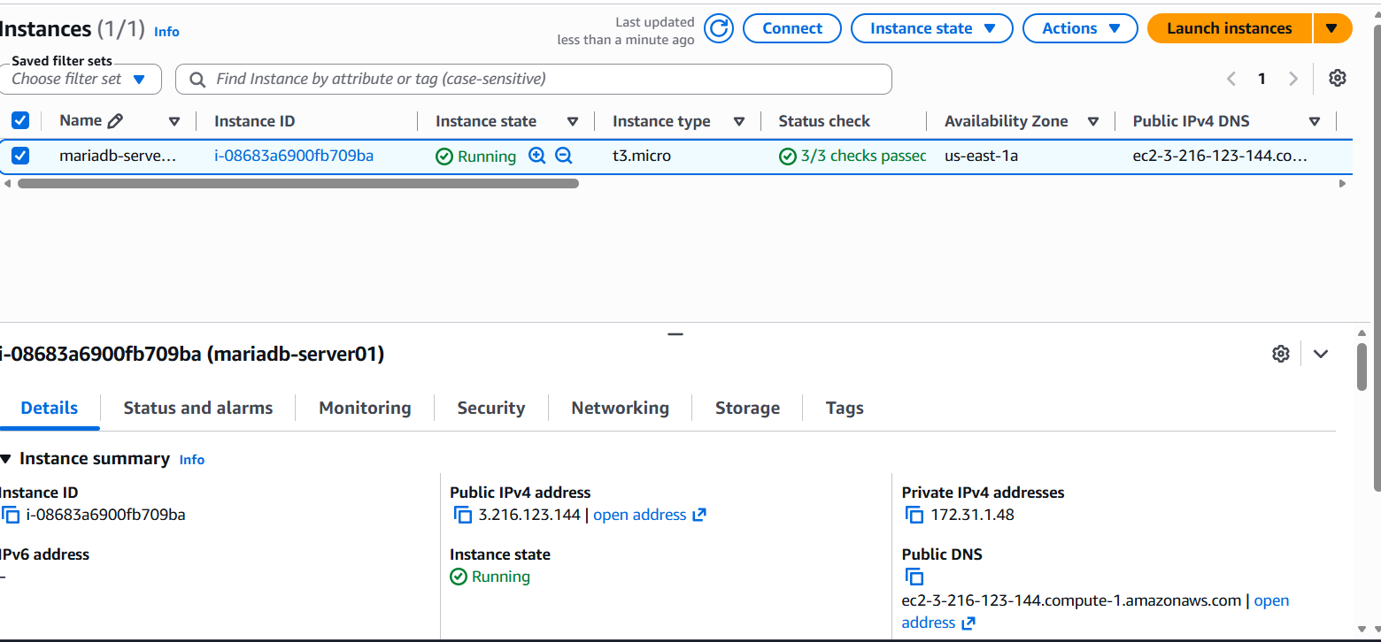
Installing the mariadb package in the server:
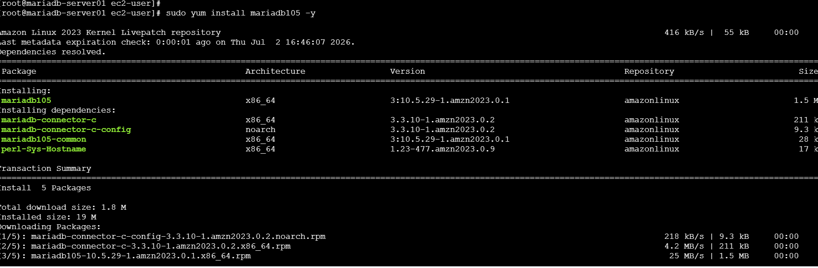

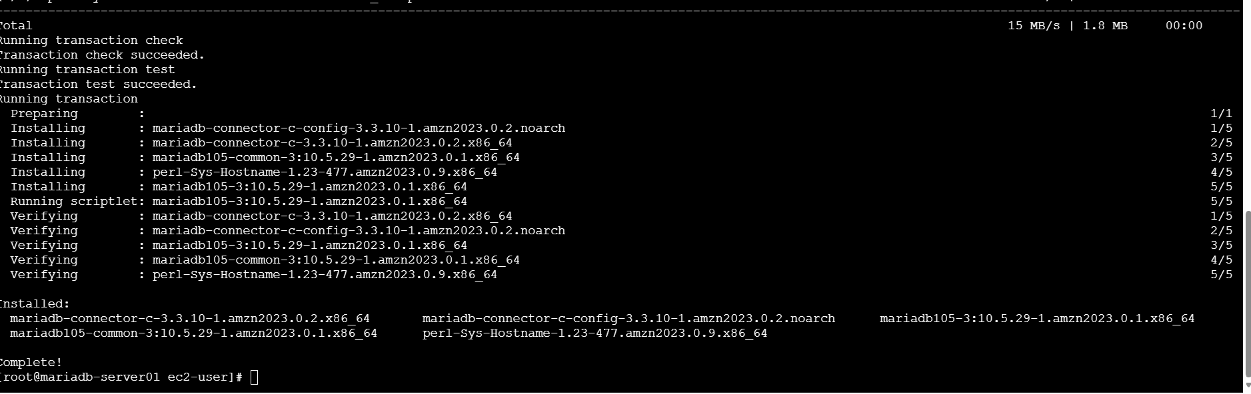
Validate the db version:
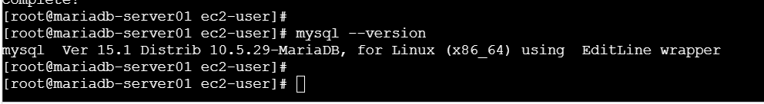
Connect the DB using the below parameters:
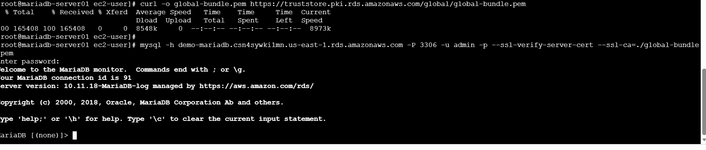
Validate the DB & retrieve the data which was inserted with the windows client:
